LATE BOOKING FORM  ABTAPL Spring Conference  Venues: Wycliffe Hall & Yarnton Manor, Oxford  Accommodation: Wycliffe Hall & St. Anne’s College, Oxford  Conference dates: Thursday 26-Saturday 28 March 2026 | 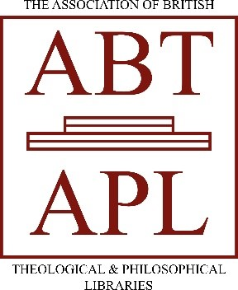
Please submit your form with confirmation of your payment to rosslynjohnston@yarntonmanor.com by the end of Wednesday 11 March 2026.
Refunds cannot be granted after 11 March. Please be sure you can attend before submitting your form.
I wish to attend the ABTAPL 2026 Spring Conference at the following fee (please tick)
 | Full | Concession *
ABTAPL member ** delegate | £350 (only non-ensuite rooms available) | £210
Non-member delegate | £395 (only non-ensuite rooms available) | n/a
ABTAPL member ** non-residential delegate | £150 | n/a
ABTAPL member ** day rate | Friday £140  Friday with meal £185  Saturday nc | n/a
Non-member day rate | Friday £145  Friday with meal £195  Saturday nc | n/a
*Concessions apply for: retired members; unwaged personal members.
**The member rate is also available to members of ANZTLA, Atla and BETH. This arrangement is reciprocal for ABTAPL delegates to ANZTLA, Atla and BETH conferences.

Delegate Name:

Institution (if applicable):

Contact postal address:

Email address:

Share email address with other delegates? | Yes / No
Daytime and/or mobile phone number

Will this be your first ABTAPL conference? | Yes / No

Contact in case of emergencies (this must not be someone attending the conference.)
Name: | Phone number: | Relation to you:

Please indicate any dietary requirements:

Please indicate any accessibility requirements:

Please indicate if you do not consent to being photographed during the conference:

BACS payment details  Please use payment ref: nameSprC26 (where name is your surname)  Account/Payee Name: ABTAPL  Bank Name, Sort Code and Account Number: Co-operative Bank; 08-92-99; 65667284  IBAN Number, Swift Code, and Routing Number (US Only):  IBAN: GB53 CPBK 08929965 6672 84  BIC: CPBK GB22 | Payment made? (Please tick if so and indicate BACS or cheque.)
We prefer direct bank payments.

Cheques should be payable to ABTAPL and returned with your form to:
Keith Lang, Librarian, London School of Theology, Green Lane, Northwood, Middlesex, HA6 2UW

Invoices or information on bursaries can be provided on request. Please contact Keith Lang at London School of Theology, Green Lane, Northwood, Middlesex, HA6 2UW abtaplinfo@gmail.com

***You are not booked until you receive confirmation from ABTAPL. If you have not heard from us by 13 March, contact Rosslyn Johnston.***

